NEW TAIPEI CITY INTERNATIONAL ART VILLAGE
RESIDENCY PROGRAM
Prospectus for In-Residence Open Audition Application
24 January 2022 – 23 January 2024
I. Purpose of Project
The New Taipei International Art Village (NTIAV) is located in Tamsui, famous for its scenic mountains and the sea. The Art Village was a training center of the Taiwan Golf and Country Club, the first golf course in Taiwan and nearby scenic spots include the Hobe Fort, the Drop of Water Memorial Hall, the Cloud Gate Dance Theatre, and the Tamsui Golf Club. NTIAV is the closest to nature among all these nearby scenic spots. NTIAV is currently managed and operated by the New Taipei City Government Tamsui Historical Museum.
To encourage artistic creation, the studio space at the New Taipei International Art Village is provided as a base for creative work, allowing artists to experience Tamsui's slow living, through in-residency in the Village and to participate in the empowerment of old mansions. The incorporation of Tamsui’s ancient monuments, historical and cultural themes add to this initiation process. Artists interested in the project are welcome to apply and participate in the selection of resident artists at the New Taipei City International Art Village.
II. In-Residence period
From January 24th, 2022 (the effective date of the Agreement) to January 23rd, 2024, the
applicant is required to submit a progress report each year following an assessment and
evaluation. Those who pass the two yearly evaluations and assessments may renew the
Agreement for one year.
III. The environment at the In-Residence Village
(1) NTIAV and its surrounding landscape
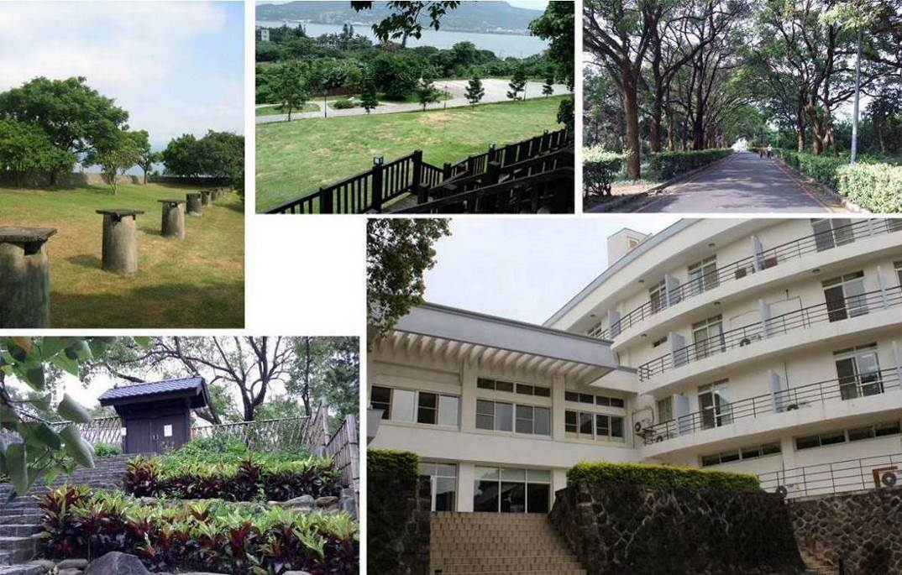
NTIAV address: No. 32-2, Lane 6, Section 1, Zhongzheng Road, Tamsui District, 251015, New Taipei City. 251015新北市淡水區中正路一段6巷32之2號
The New Taipei City International Art Village is located on the third floor, whereas the In-Residence studios are on the fourth floor. The offices of the Administration Center and the New Taipei City Government Tamsui Historical Museum are on the first and second floors.
(2) In-Residence Space at the New Taipei City International Art Village
Floor | Area |  | Number of currently available rooms
3 | Small studio 29.8 m2 |  | 4 rooms (301, 303, 304, 305)
4 | Small studio 29.8 m2 |  | 3 rooms (403, 404, 405)
4 | Large studio 59.6 m2 |  | 1 room (402)
A |  | B | C(402)
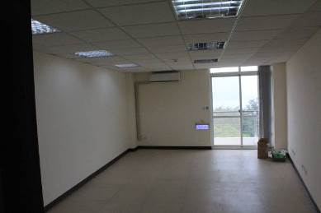 |  | 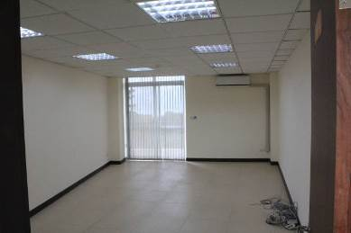 | 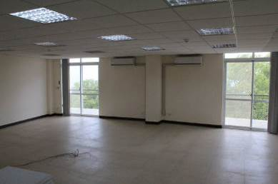

(3) Other public spaces
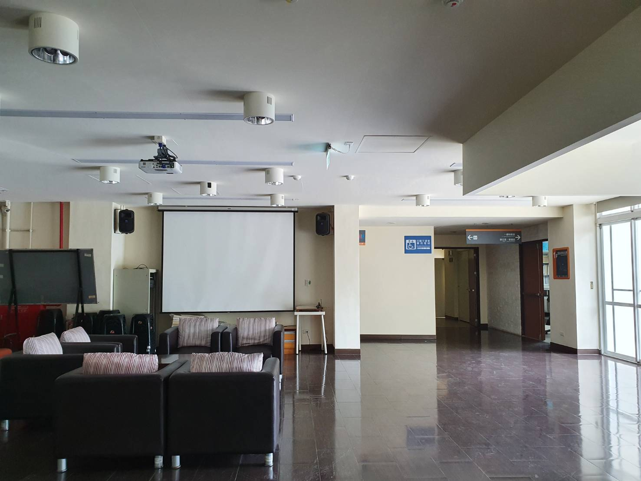 | 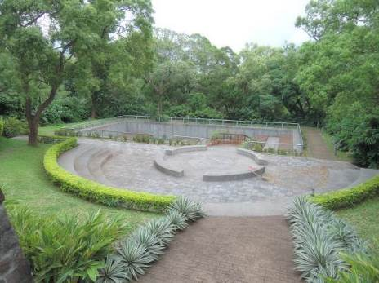
1F Art Exchange Hall | 1F Outdoor theater
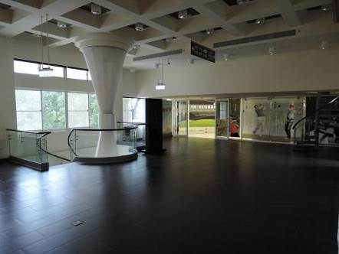 | 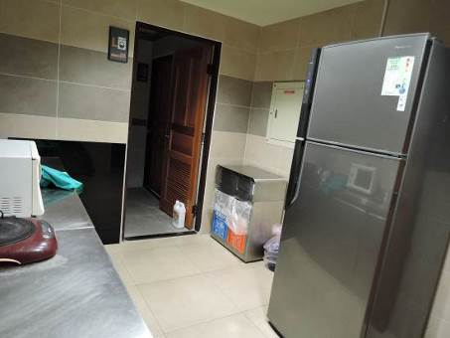
2F Entrance Lobby | 4F Pantry room (water dispenser, refrigerator, washing machine)
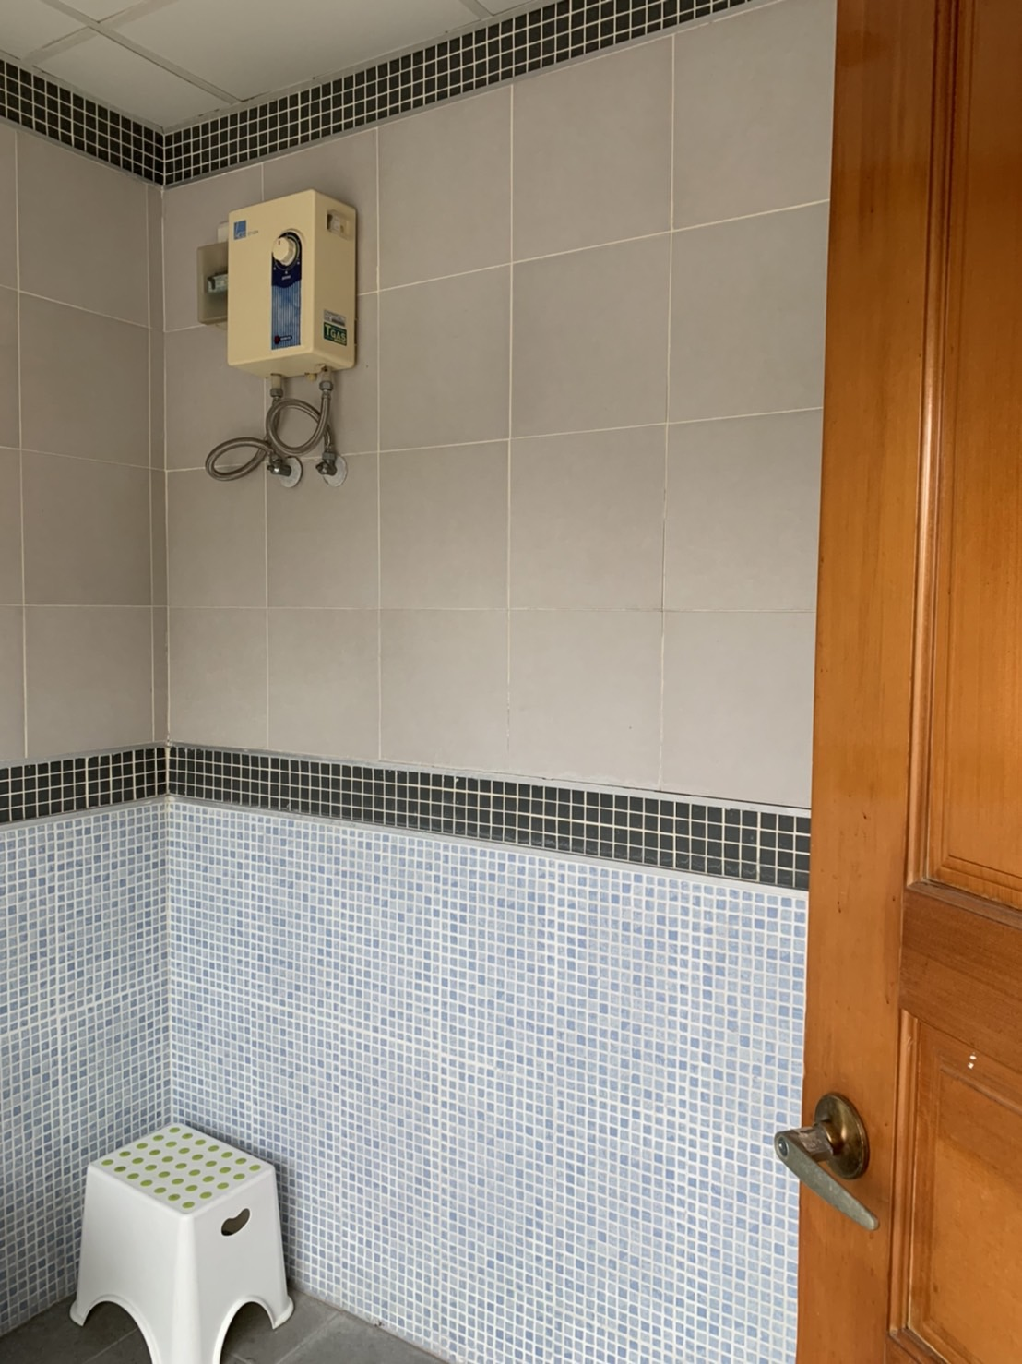
4F Bathroom

IV. Eligibility for application and quota available
          - Independent artists, cultural workers, design employees aged 20 years or older, or teams, regardless of nationality, can apply for in-residency. However, group size will be limited to a maximum of 4 persons only (Foreign individuals who can communicate in Chinese or English are preferred; they must also personally apply for their resident visas and extension or Work Permit for Foreign Freelance Artist).
(2) 8 studios are available for open application (7 small studios and 1 large studio). Foreign artists are guaranteed 1 reserved seat; however, if appraised to be ineligible, the reserved seat will be declared vacant and will be filled by a native artist.
V. Application time and methods
(1) Deadline: From the date of announcement to 17:00 on (Friday) December 24th, 2021.
(2) Submission method: Fill in the open audition proposal application (including the application form, In-Residence proposal, and portfolio of works for review) are completed as detailed in【Appendix 1】, all applicants shall forward their forms by email under the subject “Application for New Taipei City International Art Village” to ao2225@ntpc.gov.tw.
(3) Other important matters
- Excessively large attachment or photograph files should be uploaded onto a network space or a cloud drive by the applicant. The applicant must also provide the relevant link or address in the application mail. The maximum file attachment size is 300 MB.
- If the applicant does not receive a reply mail from the New Taipei City Government Tamsui Historical Museum after submitting the required documents, the applicant is recommended to call the Museum to confirm it has received the mail.
- Contact Number: (02)2621-2830, ext. 212. Ms. Chang of the Exhibition and Education Section; contact between 9:00–12:00 and 13:30–17:30 from Monday to Friday.
VI. Review Methods
(1) Primary review: The Museum reviews all written application documents (including the application form, In-Residence proposal, and portfolio of works for review). Those that do not conform to the requirements will be notified to supplement the required documents to the Museum within a limited period (usually within 3 working days). Applicants failing to supplement the required documents within the given period will be disqualified.
(2) Secondary review: The review committee reviews the In-Residence applications of applicants who have satisfied the criteria of primary review. The applicant or representative is asked to briefly describe their In-Residence project.
(3) The secondary review time will be individually communicated to the person who has passed the primary review. Those unable to attend will be reviewed in writing.
(4) Review standards
1. Quality and style of works 30%
2. Completeness and feasibility of project 30%
3. The interconnectivity of the feedback project contents, the creative theme, and the Tamsui historical sites accounts for 30%.
4. Team experiences (related experience to this project) 10%
5. Those with an average score of fewer than 75 points shall be considered unqualified.
Notes:
- If the feedback project content includes Arts Education or teaching cooperation projects with primary and secondary schools in the Tamsui area, it is preferable to propose a curriculum or workshop project that is suitable for cooperation with schools, and then the Museum will help match primary and secondary schools in the area to handle the project.
- It is preferable to combine the feedback project with the Museum's important annual activities, such as the children's summer camp activities, the Sparking-Tamsui series of activities, and so forth. For more information on these related activities, please visit the Tamsui Historical Museum website.
VII. Result announcement
- The list of selected artists is expected to be announced in the "Latest News" webpage before (Monday) January 17th, 2022 (subject to the actual operating situation) on the official website of the Tamsui Historical Museum. Each selected party will be notified individually.
- The selected teams must inform of their willingness to take up the In-Residency within 5 days of receiving the notification and complete signing of the In-Residence Agreement within the stipulated period. Those who fail to finish the required procedure within the period will be disqualified; space will then be attributed to the next artists on the reserve list. The disqualified applicants shall not object. If a team selected for In-Residence wishes to leave early, the Museum can arrange for the team to be replaced by the next team in the list after the end of the In-Residence admission time.
VIII. Rights and obligations
- Refer to【Appendix 2】.
(2) Equipment and resources:
1. Studio:
- A studio key, an air-conditioning device, Internet, a rack, and a shelf are provided in the room. Desk and chair sets can be provided with a maximum Number of four sets depending on the Number of applicants.
- No other equipment or decoration is provided in the space. The In-Residence artists should decorate the space themselves; however, they are not allowed to damage the structure's safety or foul up the environment.
2. Public space:
- 1F: Art Exchange Hall, Conference area, and outdoor theater; 2F: Entrance Lobby; 3F: Large conference room (with projector equipment); applicants must register for using the facilities with the Museum personnel responsible for In-Residence matters.
- 4F: Pantry room (including a water dispenser, a refrigerator, and a washing machine) and a bathroom. In-Residence artists can use these facilities freely. Foods stored in the refrigerator must be labeled with the owners’ names. The Museum will assign cleaners to clean the refrigerator periodically.
3. Other needs related to work or In-Residence equipment (e.g., easel or hooks) must be informed in the application documents. The Museum will provide necessary supplies as required during the In-Residence period.
4. A provision of TWD10,000 in funds is made for In-Residence Achievement Display and activity-related consumables for each studio. According to the rules of the New Taipei City Government for verification operations, invoices (receipts) and pictures must be produced for reimbursement on actual expenses such as the purchase of materials for exhibitions, feedback activities, printing design, transport, and so on. It shall not include personnel costs (such as lecturer fees, performance expenses), business trip expenses, and transportation costs.
(3) The In-Residence art teams shall share part of the water and electricity bill of NTIAV (No. 32-2, Lane 6, Section 1, Zhongzheng Road, Tamsui District, New Taipei City; electricity bill customer Number: 16-61-0108-13-6; water bill customer Number: 1B-21-1331-16-2). In-Residence users in large and small studio rooms shall share 6% and 3% of the bills, respectively. The effective date begins from the day the In-Residence Agreement is signed by both parties.
December 2019 to March 2020 Contribution of utilities provided for reference: TWD2,730 for the small studio, TWD5,460 for the large studio.
(4) Cooperative measures:
1. During the In-Residence period, the In-Residence artists must participate in the In-Residence Outcome Exhibition and Activities planned by the Museum every year. In addition, in case of early termination, those who have been In-Residents for less than a year and will not be able to participate in the Outcome Exhibition and Activities shall be required to give a presentation on their achievement. The Museum reserves the right to coordinate the changes in exhibition venues.
2. In-residence teams must comply with the provisions of the NTIAV In-Residence Agreement (Appendix 2) and Daily Activities Agreement (Appendix 3). Facilities and equipment must be checked before and after In-Residence. The equipment list is provided in Appendix 4.
3. The In-Residence teams shall cooperate with the marketing events arranged by the Museum; they shall receive filming of individual activity for documentaries and interviews.
4. The In-Residence teams in the large and small studios shall respectively host at least 6 and 4 feedback projects (sessions) every year as shown in the plan below, and shall submit a proposal for online implementation of the feedback program.
1. To coordinate with the Museum for its time to organize dynamic art and cultural performances such as art education, DIY, lectures, performances, and workshops in the Museum's space (including the International Art Village and the various Tamsui monuments and operational sites under its management) or the Tamsui area's primary and secondary schools, and communities without remuneration.
2. The feedback project content includes Arts Education or teaching cooperation projects with primary and secondary schools in the Tamsui area. You can propose suitable cooperation with the school curriculum or workshop project, and then the Museum will help match primary and secondary schools in the area to handle the project.
3. The feedback project will be combined with the Museum's important annual activities, such as the children's summer camp activities, the Sparking-Tamsui series of activities, and so forth... For more information on these related activities, please visit the Tamsui Historical Museum website.
4. The artists shall decorate the inner space of the studio rooms for celebrating festivals including the Chinese New Year, Lantern Festival, International Museum Day, and Christmas. However, since the spaces of the Museum are mostly historical structures, painting, coloring, or renovation works are prohibited.
5. The artists provide design, illustrations, and video-based cultural and creative industry plans free of charge to the Museum to market the local culture. The artists’ works may also be used by the Museum for storage, exhibition, and other educational and promotional purposes.
6. The feedback projects have to include online plans, such as online teaching or creating videos or social media interactive events, etc.
7. In-Residency for shorter than 6 months is deemed to be counted as 6 months; the feedback sessions are thus halved. Artists in large and small studio rooms shall, therefore, need to host three and two feedback sessions respectively.
(5) Subject to the nature of the In-Residence team, the In-Residence workshop will be made available.
(6) Submit the annual achievement report before January 10th of each year, providing evaluation and record keeping.
- Owing to security factors, epidemic prevention, and access control, the Artist Village is not open for overnight stays in principle, but those with specific needs may apply individually.
- Other matters not covered in this document shall be negotiated by both parties.

【Appendix 1】
New Taipei City International Art Village
In-Residency Recruitment Application Form
Number: (completed by the Museum)
Name of the team: (for individual applicants, the real name, alias, or any preferred name can be filled here)
In-Residence period | From_______________(DD/MM/YYYY) to _______________ (DD/MM/YYYY)  (From January 24th, 2022 till January 23th, 2024 ; a minimum of 1 year to a maximum of 2 year of In-Residency, the time should be filled in depending on the applicants’ needs)
Desired studio room Number in order of priority | 1. | 2. |  | 3. |  | 4. |  | 5.
Address of the representative
The email address of the representative
Phone Number of the representative | (Cell phone, office phone, and home phone numbers should be provided as well as the preferred contact time to  facilitate connection)
Photographs of the members  (Passport port photos of 2.9 cm× 3.9 cm or 3.7 cm × 4.8 cm sizes or personal photos or images cut from selfies that can reveal clear facial contour and features can be used. The representative’s photo should be attached to the leftmost cell.) | 
Name
ID card Number
(Resident visa Number for foreign applicants)
Date of Birth
(e.g.,19XX/XX/XX)
Contact Number (cell phone recommended)
Emergency contact person
Relation
Phone Number of an emergency contact person
Note: The studio assignment is arranged by the curator according to the selected person's wish and the ranking of the review scores.
Other needs | (e.g., easels, hooks, or any other In-Residence equipment you need)
Applicants’ ID card or passport copies | Please attach the front and back copies of the ID cards (or Alien Resident Certificate or passports for foreign applicants) of all members. Scanning images or photographs uploaded through a computer are acceptable.
Applicants’ ID card or passport copies | (Front) |  |  |  | (Back)
Applicants’ ID card or passport copies | (Front) |  |  |  | (Back)
- After carefully reading the requirements of the application to New Taipei City Government Tamsui Historical Museum, I propose this application in accordance with regulations. If the application is approved, I will follow the relevant regulations as noted.
- I hereby declare that all information and attachments provided in the application documents and proposals are facts.

(Seals of the application unit and applicant)

【Team Name】In-Residency Proposal
- A brief introduction to the applicant team
- Team structure and establishment purpose
- Specialty
- Members’ educational background and experience
- Recent outcomes
- Awards
- Creation Project
(1) Projected creative works during the In-Residence period (describing the connectivity of the Tamsui area and the Tamsui monuments)
(2) Creative exhibition project (including domestic and international exhibitions and In-Residence Outcome Exhibition)
(3) Expected outcome
※Use at least 500 words to describe this project, with photos and illustrations

- Feedback Projects
- A brief description of the projects and contents of the feedback program (expected to conduct school arts cooperation projects, museum activity cooperation projects, arts promotion activities, feedback performances, and so forth as listed in the brief)
- Online execution of alternative planning
- Expected outcomes and benefits (e.g. number of participants in the event)
- Others (e.g. marketing and promotion plan, cooperation with schools and organizations, etc.)
※Use at least 500 words to describe this project, with photos and illustrations
- Space Usage Planning
Planning the use of studio space according to the creative profession, detailing the spatial planning and functions, including usage planning, simplified schematic diagram, explanations, and so forth.
- Planning the Implementation Period (January 2022 to January 2024)
(Space and In-Residence planning and contents of feedback project implementation are to be provided in the form next page.)
6. Appendix (Registration certificate or proof of holding relevant art and cultural events, such as photographs …and so on)
※Not exceeding five A4 pages in principle

New Taipei City International Art Village In-Residence Project Implementation Time Plan
In-Residence period: Name of Artist/Art Team:

Year | Month | Item | Specific Practice
2022
2023

2023
2024
※ The size of this form can be adjusted freely.

Portfolio of Works for Review
◎2D/3D works
Category |  | □ 2D type  □ 3D type | Attachment | A total of _______________ works
Number | Author name | Work title | Year of creation | Material | Size (H*W) | Picture of the work
1
2
3
4
5
6
7
8
9
10

◎Video/Dance
Work sequence | Author and work name | Year of presentation | Place of release | Brief explanation | Length  (minutes/ seconds)
1
2
3
4
◎Attachment
A downloadable link of the image, video, or audio files.

【Appendix 2】
新北市國際藝術村
駐村契約書
New Taipei City International Art Village
In-Residence Program Agreement
新北市立淡水古蹟博物館（以下簡稱甲方）____________________（以下簡稱乙方）
The New Taipei City Government Tamsui Historical Museum ( hereinafter called Party A)
_____________ _____________________________________( hereinafter called Party B)

經雙方同意，訂定契約書條款如下：
The terms and conditions of the Agreement mutually agreed upon are as follows:

- 使用用途
此計畫係提供新北市國際藝術村 工作室(空間範圍詳本進駐計畫簡章)予乙方，乙方得於甲方所指定之前述空間內依核准之進駐計畫書使用之。
Article 1. Usage Purpose
This plan is meant to provide Party B with the Studio Number_______ at the New Taipei City International Art Village (Refer to In-Residence Program Agreement General Rules for the range of spaces). Party B shall use the space according to the In-Residence proposal which has been approved by Party A.

- 使用期間
- 自______年___月___日至______年____月____日止，共計____年。乙方每年應提交成果報告，並配合接受評鑑考核。
- 乙方應依申請計畫所提報之進駐期間如期使用，除經甲方同意者外，不得延長；乙方自進駐日起將獲配鑰匙1支，可於進駐期間自由進出國際藝術村，經甲方同意後可複製鑰匙供同組其他創作者使用，鑰匙須妥為保管，並須於辦理離館手續前歸將所有鑰匙(含複製鑰匙)歸還甲方。
Article 2. Period of Use
- From dd/mm/yyyy to dd/mm/yyyy. A total of ____ years. Party B shall submit an achievement report every year and cooperate in accepting evaluation and assessment.
- Party B shall use the space following the In-Residence proposal applied for and the period of use shall not be extended unless permission is granted by Party A. Party B shall be given a key from the day of residency to go in and out of the International Art Village freely. Party B may make duplicate keys to share with his/her/its other workers provided Party A permits so. The keys (including the duplicate ones) shall be kept carefully and returned to Party A before Party B checks out.
- 水電費分擔
- 乙方進駐藝術村使用場地，應分擔新北市國際藝術村（新北市淡水區中正路一段6巷32之2號，電號16-61-0108-13-6，水號1B-21-1331-16-2）百分之______的水、電費。
Article 3. Sharing of Water and Electricity bills
- Party B shall share ______% of the water and electricity bill of New Taipei International Art Village (No. 32-2, Lane 6, Section 1, Zhongzheng Road, Tamsui District, New Taipei City; Electricity bill customer Number: 16-61-0108-13-6; Water bill customer Number: 1B-21-1331-16-2).
- 房屋使用及維護
- 乙方對使用空間應盡善良管理人之注意義務，如因乙方、或乙方允許在該空間使用收益之第三人故意或過失致房屋毀損、滅失時，乙方應負損害賠償責任。如致第三人遭受損害時，應對於該第三人負損害賠償責任，如因此致甲方遭受損害〈包括國家賠償責任〉時，應對甲方負賠償責任。
- 使用空間之安全，由乙方負責，並應盡善良管理人之責，自行維護進駐空間環境整潔、冷氣機濾網清潔及設施安全，接受甲方及主管機關檢查。
- 甲方得斟酌資源調度，提供乙方使用空間借用藝術村設備資源（桌、椅、投影設備等），乙方向甲方所借之桌、椅、器材與設備，乙方應盡善良管理人之注意義務，借用完畢後歸還甲方，如有毀損、滅失時，乙方應負損害賠償責任。
- 乙方應遵守進駐空間門禁管理規範，並配合甲方要求檢查。
- 乙方應保持房地完整及整潔，不得產生任何污染髒亂或影響環境及附近居民生活環境，如構成危害，一切責任由乙方負責，經甲方勸導仍不改善者 甲方得隨時終止契約，乙方不得要求任何補償或賠償。
Article 4. The Usage and Maintenance of the Studio
I. Party B shall treat the studio with the care and duties of a good administrator. Shall Party B or if Party B allows a third party to intentionally or negligently cause the studio to be damaged or lost resulting in a loss of income, Party B shall be liable for damages. In the event the third party suffers prejudice, Party B shall be responsible for damages. In the event Party A suffers prejudice (including State Compensation Liability), Party B shall be liable for damages.
II. Party B shall be responsible for the safety and use of the space while exercising the care of a good administrator and the In-Residence environment shall be kept clean and tidy, the filters of the air conditioners are to be cleaned regularly and the safety of the facilities maintained, which shall be subject to the inspection of Party A and the competent authorities.
III. Party A may, at its discretion, allocate resources to provide Party B with space to borrow equipment resources (tables, chairs, projection equipment, and so forth) from the Art Village. The tables, chairs, equipment, and facilities borrowed by Party B and treated with the care and duties of a good administrator shall be returned to Party A upon completion of the loan. In case of damage or loss, Party B shall be liable for the damages.
IV. Party B shall comply with the access control regulations of the In-Residence space and cooperate with Party A to request inspection.
V. Party B shall keep the studio premises intact and tidy, and shall not produce any pollution or mess or affect the environmental sanitation and the living environment of nearby residents. If it constitutes a hazard, Party B shall be responsible for all liabilities; furthermore, if Party B does not improve after Party A's advice, Party A may terminate the Agreement at any time and Party B may not request any compensation or indemnity.

- 因天災、事變、特殊傳染性疾病防疫或其他不可抗力事由致無法執行第一條及第二條約定之使用用途時，乙方應即通知甲方，經甲方查明屬實者，本契約即當然終止，乙方應交回空間。
Article 5. When, as a result of natural disasters, unforeseen events, an epidemic of special infectious diseases, or other force majeure reasons, Party B is unable to make use of the space as stipulated in Articles 1 and 2, Party B shall immediately notify Party A. After Party A's verification and if found genuine, this Agreement shall be terminated and Party B shall return the space.
- 空間使用
- 乙方對於空間除依進駐計畫使用外，非經甲方書面同意，不得擅自將空間之全部或部分出租、出借或頂讓他人出租、出借或頂讓他人，亦不得於進駐空間進行任何營業行為，違者，甲方得終止契約並收回使用空間。
- 甲方保有空間使用或調整之權利，乙方進駐工作室後，甲方仍得要求乙方遷離原本工作室，而搬移至藝術村內其他工作室。
- 於辦理活動時，甲方保有空間調整之權利。
- 藝術村內嚴禁用火，為符合本館節能減碳與生態園區精神，應減少空調使用，若因天候因素（如氣溫達30℃以上）必須開空調，空調溫度請設定攝氏26℃。
Article 6. Space Usage
I. Party B shall not use the space for any other purpose than that it is planned for and shall not lease, lend or let to others all or part of the space without the consent of Party A. In-Residence artists are also not allowed to conduct any business activity in the space. In case of any breach, Party A shall terminate the Agreement and recover the space for use.
II. Party A can have usage or space adjustment needs, Party A shall be able to maintain the right to adjust space. Even after Party B has taken hold of the studio, Party A may still require Party B to move out of the original studio and transfer to other studios in the art village.
III. Party A reserves the right to adjust the space when conducting activities.
IV. The use of an open flame is forbidden in the art village. To be in line with the spirit of energy conservation, carbon reduction, and ecological maintenance of the Museum, air conditioning shall be reduced. If due to climatic factors (like temperatures of 30℃ or more), air conditioning must be turned on, it must be set at 26℃.
- 房地修繕及改建
- 乙方使用之房地，如須進行空間簡易修繕或電器設備裝設，需報甲方核准後為之。
- 乙方非經甲方同意，不得擅自增建、改建或修建房舍及其地上物，一經違反修建者，甲方即得終止契約；乙方並應於 10日內拆除回復原狀，並不得向甲方求償；乙方不為之，甲方 得逕予拆除之，並向乙方追討拆除費用。
Article 7. Renovation and alteration of the studio premises
- If the studio premises used by Party B need simple repair of space or installation of electrical equipment to be carried out, it must be reported to Party A for approval.
II. Party B shall not add, build, alter or construct the studio and its premises without the consent of Party A. Party A shall terminate the Agreement once the construction is violated; Party B shall demolish and restore the studio and its premises to its original state within 10 days and shall not seek compensation from Party A; If Party B does not do so, Party A may demolish it and recover the demolition costs from Party B.
- 乙方不得以其協議書之權利作為質押擔保或其他類似使用。
Article 8. Party B shall not use this Agreement as a pledge or guarantee or for similar use
- 乙方場地之使用須符合原提送之進駐計畫使用內容。甲方得不定期查核乙方使用情形，並作為日後申請計畫之重要參考。
Article 9. Party B shall use the space per the In-Residency plan. Party A shall check the usage of the room from time to time and inspect it as a reference to other application plans made for the future.
- 提供空間終止使用及賠償
- 有下列情形之一時，甲方得隨時終止乙方使用空間，乙方不得向甲方要求任何補償或賠償：
(一)政府實施國家政策或都市計劃或因開發利用、舉辦公共事業需要或公務需要或依法變更使用者。
(二)乙方使用空間違反法令者。
(三)因可歸責乙方之事由致毀損空間或其他設備而不負責修復者。
(四)房屋因可歸責於乙方之事由致焚毀者。
(五)乙方擅自增建、改建或修建者。
(六)乙方不依契約約定，繳納水電費用，經3次含以上催告仍不履行者。
(七)乙方未保持房地完整及整潔，致產生任何污染髒亂或影響環境及附近居民生活環境構成危害，經甲方勸導仍不改善者。
(八)乙方違反本契約之約定者。
(九)乙方違反其他依法令規定。
- 違反社會秩序維護法或相關法令者，甲方得依規定立即制止乙方繼續使用空間，甲方並得立即要求乙方撤出空間。
- 乙方如有違約情事者，除另有約定外，應負損害賠償責任，乙方如有數人，負連帶賠償責任。
- 乙方終止使用空間前，需事先詢問甲方是否依現狀交付，除本契約另有約定或經甲方同意依現狀交還外，乙方應將使用空間回復原狀返還甲方。
- 乙方於契約終止或使用期限屆滿契約關係消滅時，乙方應於屆滿當日將空間交返甲方。其留置物品經甲方通知限期仍不搬離者，視為廢棄物，任憑甲方處理，其清除處理費用由乙方負擔。
Article 10 Termination of the Provision of Space and Compensation.
I. Party A shall have the right to terminate Party B’s usage of the space in the case of any one of the following circumstances and Party B may not ask for reparation or compensation from Party A:
(1) The government implements state policies or urban plans or, as a result of development needs, carries out public utility needs or exigencies of service or makes changes per the law.
(2) Party B uses the space against the laws and regulations.
(3) Party B damages the space and other equipment and refuses to restore the damage caused.
(4) The studio is burnt due to the responsibility attributed to Party B’s misconduct.
(5) Party B carries out the construction, renovation, or reconstruction without authorization.
(6) Party B violates the terms stipulated in this Agreement by not paying the utility bills on time and still do not perform following more than three reminders.
(7) Party B does not keep the studio premises intact and tidy, and produces any pollution or mess, or affects the environmental sanitation and the living environment of nearby residents, thereby constituting a hazard, and fails to improve after Party A's advice.
(8) Party B breaches the terms of this Agreement.
(9) Party B violates other provisions of the law.
II. In the event Party B violate the Social Order Maintenance Act or related laws, Party A may immediately stop Party B from continuing to use the space as per the regulations, and Party A may immediately require Party B to vacate the space.
III. Party B shall be liable for damages for any breach of the Agreement, unless otherwise agreed, and Party B shall be jointly and severally liable for damages in the case of several persons.
- Before terminating the use of the space, Party B shall have asked Party A in advance whether the space can be returned in its present condition. Unless otherwise agreed in this Agreement or agreed to by Party A, Party B shall return the used space to Party A in its original condition.
- Party B shall return the space to Party A on the date the Agreement shall be terminated or expires. In the event Party B has not taken out his/her/its remaining belongings within the time limit after Party A's notification, they shall be deemed to be abandoned. Party A will dispose of it and Party B shall be responsible for the clearance and processing expenses.
第十一條 乙方於使用期間內擬提前終止使用空間者，應於1個月前以書面向甲方提出申請，經甲方書面同意後，使得終止本協議，乙方不得向甲方要求任何補償或賠償。
Article 11 Shall Party B intend to terminate the use of the space in advance, Party B shall submit a written application, to Party A, one month beforehand and the Agreement shall be terminated if Party A consents to it. Party B shall not ask Party A for any reparation or compensation.
第十二條 乙方應擔保其著作及申請計畫無侵害他人著作權之情事，若此情形發生致使甲方名譽遭受損害或受連帶賠償請求之損失，由乙方負全部賠償責任。
Article 12. Party B shall guarantee that his/her/its creations and project application do not infringe upon the copyrights of others. Shall such a situation arise and result in the loss of Party A's reputation or a claim of compensation from Party A, Party B shall be fully liable for all the damages caused and make the compensation accordingly.
第十三條 配合辦理事項及回饋計畫：：
- 駐村期間，每年需參與甲方辦理之駐村成果展示及活動；另駐村期間未滿一年者，未能參與駐村成果展示及活動，需辦理成果發表。
- 採訪紀錄：甲方為推廣、行銷目的所採訪之錄影、錄音、照片及文字紀錄，著作財產權歸甲方所有，乙方同意授權甲方活動宣傳、公關報導與展示之用。
- 進駐之團隊，大工作室每年至少辦理6（場）次之回饋計畫，小工作室每年至少辦理4（場）次之回饋計畫。駐村期間未滿半年者，以半年計，回饋場次減半。
- 進駐期間，須遵守新北市國際藝術村駐村生活規約，甲方得不定期查核 工作室空間使用狀況。
- 如因天災、事變、流行病防疫政策或其他不可抗力事由，致前述配合辦理事項難以執行，雙方得合意調整配合辦理事項內容，並辦理契約變更。
Article 13. Cooperation Matters and Feedback Program
I. During the period of In-Residency, it shall be necessary to participate in the In-Residence Outcome Exhibition and Activities organized by Party A every year; for those residents who/which have been in the village for less than one year and are unable to participate in the In-Residence Outcome Exhibition shall hold an outcome presentation instead.
II. Party B agrees to authorize Party A to disseminate publicly, report, and display its activities for promotional and marketing purposes; the property rights of the video, audio recordings, photos, and written records of the interviews shall belong to Party A.
III. During the period of In-Residency of the art and cultural creative teams, the large studios shall host at least 6 Feedback Projects yearly and the small studios, 4 Feedback Projects yearly. For those teams with less than half-year residency, it will be considered as a half-unit, thus the Number of Feedback Projects to be hosted shall be halved.
IV. During the In-Residency period, the New Taipei City International Art Village In-Residency Living Protocols shall be observed and the use of the studio space shall be checked by Party A from time to time.
V. If the above-mentioned matters are difficult to implement due to natural disasters, incidents, epidemic prevention policies, or other force majeure reasons,
both parties may agree to adjust the content of the cooperation matters and to make changes to the Agreement.
第十四條 年度評鑑考核
- 檢核方式：為了解藝術家進駐空間使用情形及進駐效益，甲方得邀集學者專家學者組成評鑑小組，進行年度成果評鑑。
- 評鑑指標如下：進駐空間使用及維護情形（25%）、年度創作計畫履行情形（25%）、回饋計畫履行情形（40%）、生活規約日常抽檢紀錄及費用、資料繳納逾期等相關紀錄（10%）。
- 成果報告：申請者須於每年1月10日前，繳交前一年度進駐成果資料一式8份，逾期者將作成紀錄，納入下一年度評鑑結果。
- 年度評鑑平均分數達75分以上為及格，不及格者應於一個月內進行改善，再由甲方辦理複評，若仍未達及格標準者須撤離進駐空間，不得異議。
- 使用期限期滿，乙方如有意繼續使用1年，應於期滿前2個月主動向甲方提出申請並繳交成果報告，經甲方之考核委員考核通過後另簽訂書面契約，考核平均分數未達75分者不再續約。
Article 14 Annual appraisal and evaluation
- Validation method: To understand the usage and effectiveness of the artist's In-Residence space, Party A may invite a panel of scholars, experts, and academics to conduct the annual evaluation.
- The evaluation indicators are as follows: the usage and maintenance of the In-Residence space (25%), the performance of the annual creation plan (25%), the performance of the feedback plan (40%), the daily sampling records of the living protocols and the records related to the late payment of fees and data (10%).
- Achievement Report: Applicants must submit 8 copies of the previous year's In-Residency results by January 10 of each year; late submissions will be recorded and included in the next year's evaluation results.
- The average score of 75 marks or above in the annual evaluation is considered a pass, and those who fail should improve within one month, and then Party A will handle the re-evaluation, and those who still fail to reach the passing standard shall be withdrawn from the In-Residence space without any objection.
- If Party B intends to continue to use the service for one year, it shall apply to Party A and submit the achievement report 2 months before the expiration date. After passing Party A's evaluation committee assessment, Party B shall sign another written Agreement. The Agreement will not be renewed if the average score of the assessment does not reach 75 marks.
第十五條 爭議處理：
    - 本契約雙方應依誠信原則確實履行，如有涉訟，以臺灣新北地方法院為管轄法院。
    - 如因乙方違反本契約涉訟，甲方所支付之訴訟費及律師費概由乙方負擔。
Article 15. Dispute Settlement.
I. Both parties shall perform this Agreement based on the principle of integrity. In the event of any litigation, the Taiwan New Taipei District Court shall be chosen as the jurisdiction court.
II. Shall Party B be involved in litigation for breach of this Agreement, Party B shall be responsible for all the litigation costs and attorney fees paid by Party A.
第十六條 本契約如有未盡事宜，依善良、友好、公平、合理之原則解釋之。
Article 16. In the event of any matter not covered in this Agreement arising, it shall be dealt with under the principles of kindness, friendliness, fairness, and reasonableness.
第十七條 駐村藝術家徵選申請簡章、乙方提供之駐村申請文件經甲方同意者、契約本文及其附件、變更或補充文件，皆為本契約之一部份。
Article 17. The "New Taipei City International Art Village House of Memory Project – Prospectus for In-Residence Open Audition Application" and the documents provided by Party B following the approval of A shall form part of this Agreement.
第十八條 本契約得經立約人同意後，以書面修正或補充之。
Article 18. This Agreement may be amended or supplemented upon the consent of both parties.
第十九條 本契約1式4份，正本2份、副本2份，經立約人簽章後生效。正本由甲、乙方各執乙份，副本由甲方保管。
Article 19. This Agreement is made in quadruplicate, two originals, and two copies, and becomes effective upon the apposition of the signatures and seals of both the parties concerned. Both parties shall keep one copy of the original Agreement and Party A shall keep the two duplicate copies.
甲 方：新北市立淡水古蹟博物館
代 表 人：黃麗鈴館長
地 址：251015新北市淡水區中正路1段6巷32-2號
電 話：（02）2621-2830

Party A: New Taipei City Government Tamsui Historical Museum
Representative: HUANG, LI-LING Curator
Address: No.32-2, Lane 6, Section 1, Zhongzheng Road, Tamsui District, New Taipei City
Telephone: 02-2621-2830

Party B: (Signature of Representative)
Address:
Telephone Number:

中華民國111年 月 日
This ___ th day of ______________, 20_______
【Appendix 3】
新北市國際藝術村駐村生活規約
New Taipei City International Art Village In-Residency Living Protocols

- 為落實新冠肺炎防疫及維護駐村人員安全，進出藝術村需於警衛室登記簽到退時間，晚上10時至早上6時之間禁止出入藝術村，工作室不提供住宿，如有特殊需求需於1個月前另提出申請，未經核准不得夜宿。
To implement the prevention of the novel coronavirus, COVID-19 and to maintain the safety of the In-Residence personnel, you must sign-in and sign-out respectively at the Security Room indicating your time of entry or exit from the Art Village. It is strictly forbidden to enter or leave the Art Village between 10:00 PM and 6:00 AM. The studio does not provide accommodation. If you have special needs, you must submit a separate application one month in advance. You cannot stay overnight without prior approval.
- 工作室如有訪客需於3個工作天前提出申請登記，未經核准訪客不得進入。
Any visitor to the studio must apply for registration 3 working days in advance, and visitors are not allowed to enter the premises without prior authorization.
- 就本館藝術村1樓藝術交流大廳、1樓與3樓會議室等場地借用，4小時以內短時段之場地借用，請於場地使用日3日前向本館承辦人員申請；超過4小時至2日以內場地借用，前1週向本館承辦人申請；超過2日之長時段場地借用，前2週向本館承辦人申請。
For use of the Art Exchange Hall on the first floor, conference areas on the first and third floors, for shorter than 4 hours, the applicants must issue the application to the responsible personnel 3 days in advance. If the use duration is between 4 hours and 2 days, the applicants must apply for the application 1 week in advance. For long-term use over 2 days, the applicants must apply for using the areas 2 weeks in advance.
- 駐村團隊如欲使用2樓大廳辦理講座或工作坊活動，請於前1個月前向本館承辦人申請。
If an In-Residence team intends to use the Lobby on the second floor to hold lectures or workshop events, they must apply to the responsible personnel a month in advance.
- 駐村團隊使用場地應維持環境整潔與安寧，共用空間勿堆放私人物品（如浴室等），避免影響他人；；週一至週五中午12時30分至下午1時30分為館方行政人員午休時間，駐村團隊使用場地應降低音量。
When In-Residence teams use public spaces, they must keep environmental cleanliness and discipline to avoid disrupting others. Please do not pile up personal belongings in the shared space (e.g. bathroom, etc.) to avoid adversely affecting others. The period from 12:30 to 13:30 from Monday to Friday is the lunch break of the Museum’s administrative personnel; In-Residence teams using the public spaces during this period should lower their voices.
- 駐村團隊可自行使用4樓冰箱，並請於保鮮期內食用完畢，本館清潔人員將定時清理冰箱；另因本館活動或清潔需移動冰箱內存放物，請駐村單位配合館方人員指示。
The In-Residence teams can freely use the refrigerator on the fourth floor. Foods should be consumed before expiration. The cleaners of the Museum will clean the refrigerator at regular intervals. If the Museum needs to move stocks in the refrigerator because of any Museum event or cleaning requirement, the In-Residence teams should comply with the instructions of the Museum personnel.
- 藝術村內每月一次不定日進行公共空間環境消毒，若駐村單位於藝術村內遇上消毒人員行消毒施作，為避免駐村團隊吸入消毒水影響健康，請配合消毒人員指示，離開藝術村或待於藝術家工作室中。
NTIAV undergoes environmental disinfection of the public spaces once a month at a date to be announced. If the In-Residence teams encounter disinfection practices in NTIAV, they should follow personnel’s instructions to leave NTIAV or stay in their studio rooms to avoid inhalation of the disinfectant chemicals that may compromise their health.
- 駐村團隊使用工作室，請維持環境清潔並定期清理垃圾，並統一置於藝術村4樓定點垃圾桶（一般垃圾、資源回收與廚餘），另避免自外攜帶垃圾至館內丟棄。清洗餐具後，請將流理臺水槽濾網殘餘廚餘一併清理，避免孳生蚊蟲。
The In-Residence teams should maintain the environmental cleanliness of the studio room and remove their garbage periodically. Trash, recyclable resources, and leftovers should be placed at a fixed spot on the fourth floor of NTIAV. The teams should not bring garbage from outside and discard it in the Museum. After washing dishes, please clean the kitchen counter and the residual food waste from the sink strainer to prevent mosquitoes from breeding.
- 請駐村團隊減少高負載電力設備之使用，以避免跳電。
In-Residence teams are invited to reduce the use of high-load electrical equipment to avoid power tripping.
- 使用廁所請勿將異物（含衛生紙、濕紙巾、面紙）丟入馬桶避免阻塞，隨手關燈。
When using the toilet, please do not throw in foreign objects (including toilet paper, wet tissues, facial tissues) into the toilet to avoid clogging, and turn off the lights when exiting the restroom.
- 使用洗衣機後，請自行清理洗衣機網棉絮。
After using the washing machine, please clean the lint filter of the washing machine by yourself.
- 藝術村內全面禁止用火、聚眾飲酒及吸菸。
Lighting a fire, drinking, and smoking are strictly prohibited in the Art Village.

駐村團隊______________________同意以上「新北市國際藝術村生活規約」各項條款。
The In-Residence team___________________ agrees on following the regulations as stated herewith in the New Taipei City International Art Village In-Residency Living Protocols.

Representative(立書人): (Signature of Representative)
Date(日期):
【Appendix 4】 新北市國際藝術村
工作室使用設備清單
New Taipei City International Art Village
Studio room ______’s equipment and facility list

In-Residence team name(駐村團隊名稱):
In-Residency period(駐村日期):

借用物品 | 借用日期 |  | 借用人  簽收 |  | 館方人員簽收 |  | 歸還日期 |  | 借用人  簽收 | 館方人員簽收 | 備註
Borrowed item |  | Date of borrowing |  | Signature of the borrower |  | Signature of the Museum personnel |  | Date of return | Signature of the borrower | Signature of the Museum personnel | Note
工作室鑰匙 支
Key of the studio room
Quantity:
冷氣遙控器 支
Air-conditioning remote control
Quantity:
桌子 張
Table
Quantity:
折疊椅 張
Folding chair Quantity:
衣櫃 組
Closet
Quantity:
座墊椅 個
Chair with cushion Quantity:
置物架 個
Shelf
Quantity:

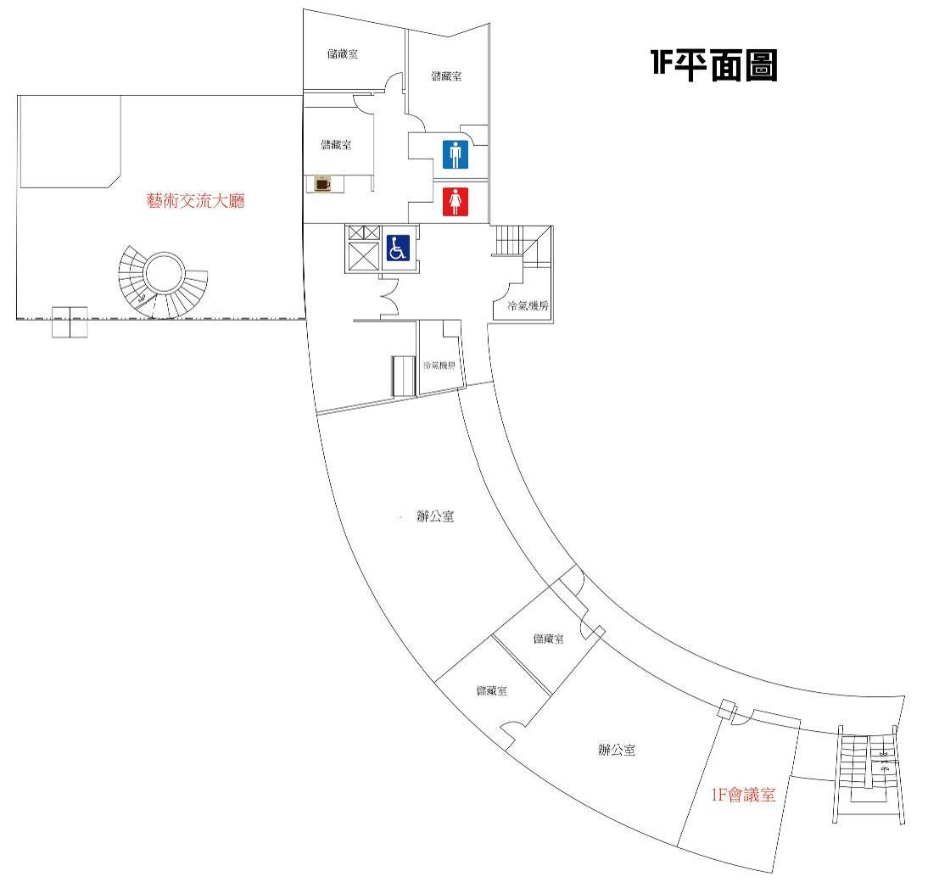
辦公室
